Day-33[Python]
Coding Challenge
Level 1: Placement Thinking
  - Number Guessing Game Store a secret number (e.g., 7)
  - Ask user to guess
  - If guess is:

o Low → print "Too Low"
o High → print "Too High"
o Correct → "You Won!" and stop
Concept: infinite while + if 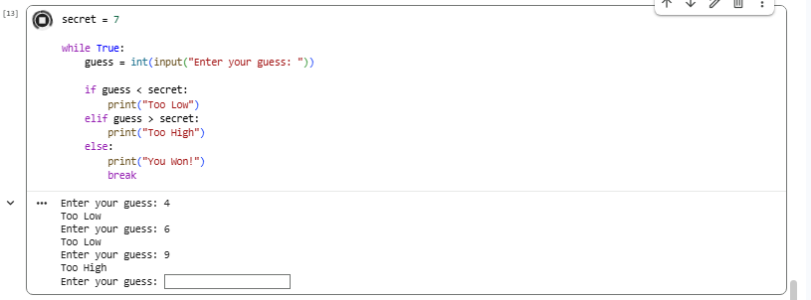
- Reverse a Number

Input: 1234
Output: 4321
Use while loop 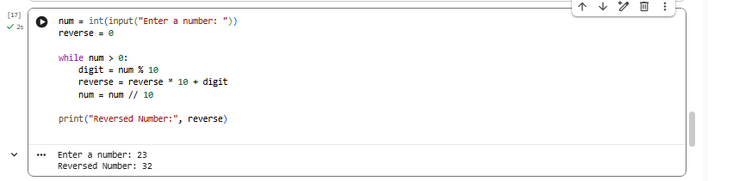
- Count Digits in Number

Input: 56789
Output: 5
Hint: keep dividing by 10 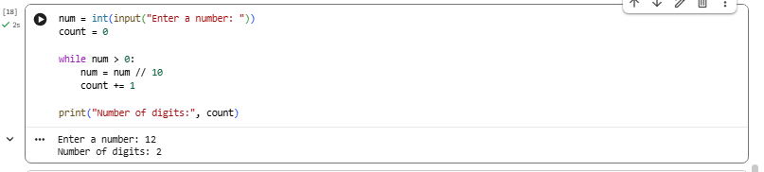
Level 2: Real-World Scenario (Data Analyst Thinking)

- Sales Threshold Checker

You have sales values:
sales = [1200, 800, 1500, 400, 2000]
Task:
- Print only sales greater than 1000
- Count how many such sales exist

Concept: loop + condition filtering (real analytics logic)
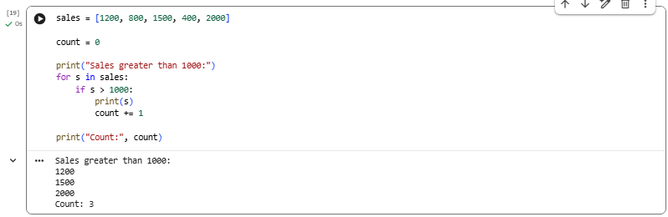
2. Continuous Data Entry System
Keep asking user to enter numbers:
- Stop only when user enters 0
- Print total sum

This is how real systems collect streaming data 